Useful Twinkl links to help support your child in phonics and reading:
1. Actions for Level 2 sounds:
https://www.youtube.com/watch?v=0SzkjubQ-Ok

2. Information about pure sounds:
https://www.youtube.com/watch?v=T7iMt_9176w

3. Twinkl Tricky Word Songs:
https://www.youtube.com/watch?v=andH6QuDoNI

4. Information about Twinkl Phonics and Rhino Reader Books:
https://www.youtube.com/watch?v=mf6Hy-dSLt8

5. An introduction to Twinkl Go:
https://www.youtube.com/watch?v=6qv7KLpv_pE

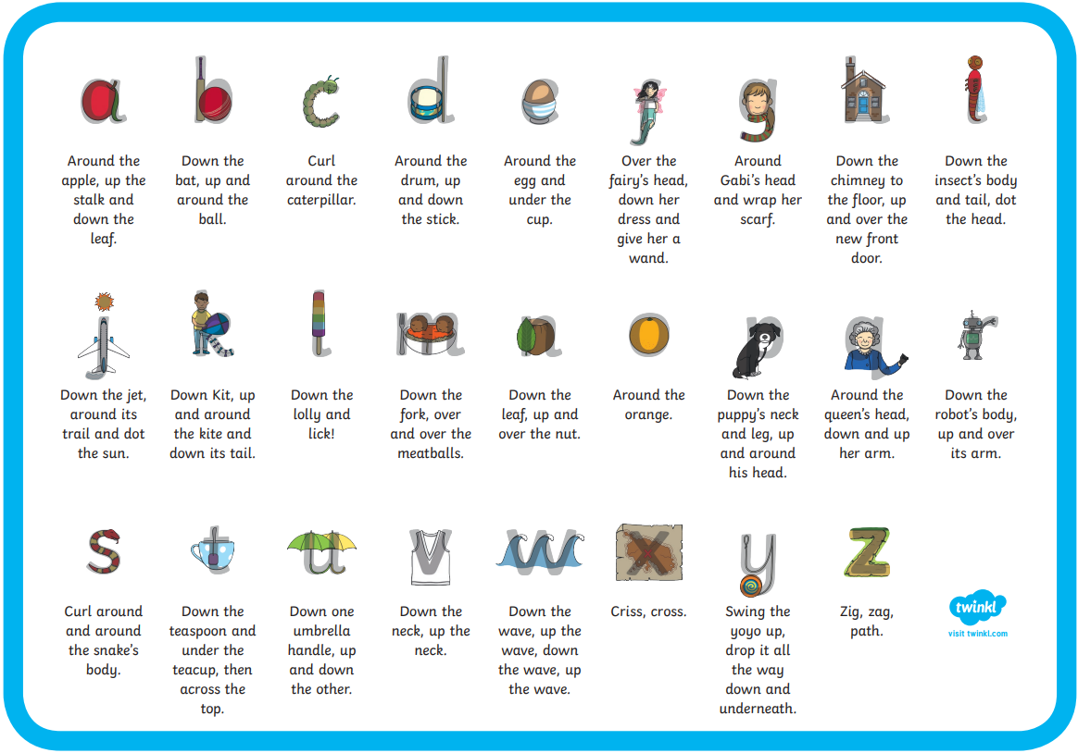

Handwriting Phrases

Resource | Code | Code Expiry
Level 2a books and resources | KT6098 | 4th November 2023

How to access Twinkl Go.
Go to https://www.twinkl.co.uk/go
Type in the access code shared by the teacher.

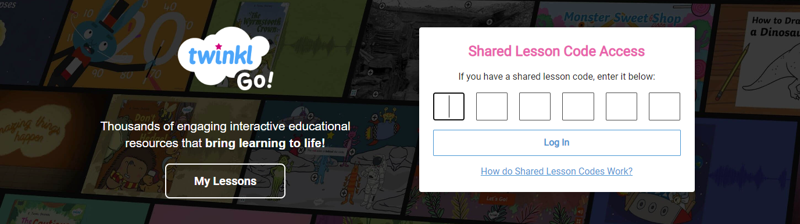

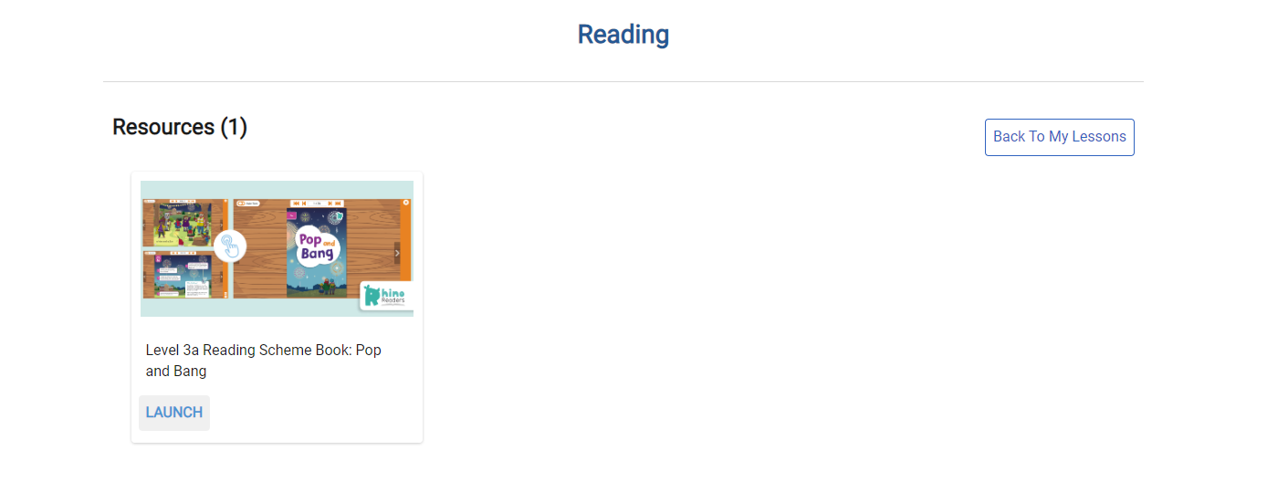
The resources will be available for you to use. Click Launch to read the book or play a game.

